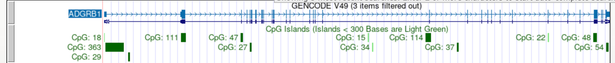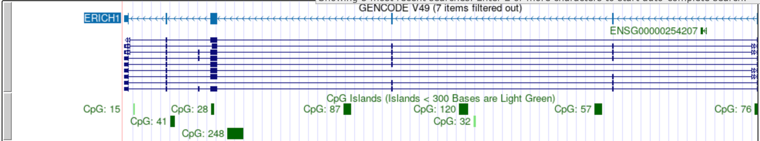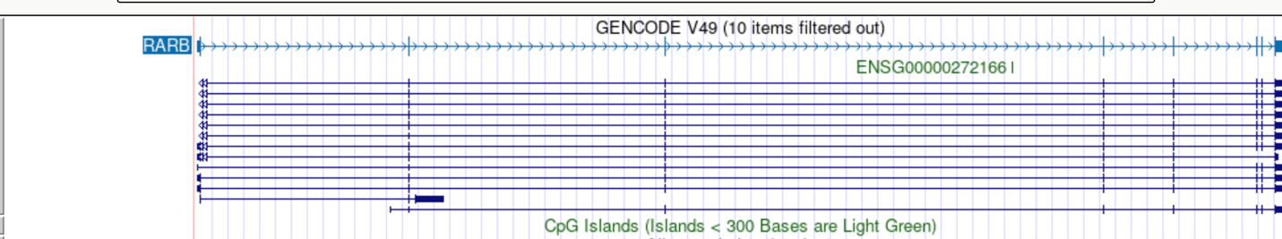
Above are the CpG islands for the three genes of choice.
The data analysis conducted on ERICH1 finds its expression difference in metastatic and nonmetastatic patients inconclusive. From the diagram, we can see that CpG 248, the largest CpG island, is not at the promotor region. This means that even if methylation differences are observed, they might not be translated into functional changes. No existing literature ties ERICH1 to metastasis either.
On the other hand, ADGRB1 has a large CpG island at the start of the transcription site, meaning that this gene’s expression might be heavily influenced by methylation.
Prior research back up the claim, the paper(cited below) ‘s finding is that ADGRB1 gene is silenced through a process of methylation at CpG cites. The gene encodes BAI1, and its absence led to accelerated tumour growth. This indicates that ADGBR1 is a tumour suppressor.

Zhu, D., Osuka, S., Zhang, Z., Reichert, Z.R., Yang, L., Kanemura, Y., ... & Van Meir, E.G. (2018). BAI1 suppresses medulloblastoma formation by protecting p53 from Mdm2-mediated degradation. Cancer Cell, 33(6), 1004–1016.

